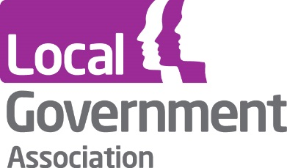

Evaluation of sector-led improvement
Interim summary report
November 2018

To view more research from the Local Government Association Research and Information team please visit: https://www.local.gov.uk/our-support/research
Contents
Introduction 1
Key findings 2
Does the approach to sector-led improvement have the continued confidence and engagement of the sector and, as a result, the trust of the public? 2
Confidence and engagement of the sector 2
The trust of the public 3
Has the LGA's support had a positive impact on the sector’s capacity to improve itself? 3
Overall sector performance 3
The impact of LGA support 3
Annex A: Progress against objectives - full research findings 5
Does the approach to sector-led improvement have the continued confidence and engagement of the sector and, as a result, the trust of the public? 5
Confidence and engagement of the sector 5
The trust of the public 6
Has the LGA's support had a positive impact on the sector’s capacity to improve itself? 7
Overall sector performance 7
Leadership 8
Peer challenge 11
Productivity 14
Data Experts Programme 18
LG Inform 19
Housing Advisors Programme 20
One Public Estate 21
Further evaluation 23
Annex B: Supporting reports 25

Introduction
This report outlines the interim findings from the four-year Local Government Association (LGA) evaluation of sector-led improvement (SLI), which is running from 2016 through to 2020.
SLI is the approach to improvement put in place by local authorities and the LGA alongside the abolition of the previous national performance framework. Full details of the approach and the support that is available can be found in ‘Sector-led improvement: our offer of support’.
Between 2012 and 2014, an evaluation of SLI and the LGA's offer was carried out, the full results of which can be found in the report, 'Evaluation of sector-led improvement'. The overall message of the evaluation was positive:
- Residents remained satisfied with and continued to trust their local council, despite the increasing financial constraints being faced by the sector.
- An objective assessment of local government performance across the full range of local government activity demonstrated that councils were continuing to improve performance, with nearly seventy per cent of the performance metrics being monitored demonstrating improvement since 2009/10.
- Further, the SLI approach and offer of support from the LGA had been welcomed and valued by councils, and there was a high level of confidence within the sector in its capacity to monitor its own performance and improve.
This latest stage of the evaluation has been running since 2016 and will continue until 2020, with the main aim of understanding whether, in the context of reduced resources within the sector:
- the SLI approach has the continued confidence and engagement of the sector and, as a result, the trust of the public
- the LGA's support has had a positive impact on the sector’s capacity to improve itself.
A further key aim of the evaluation is to provide information that will enable the LGA to continue to refine and improve the approach and support offer to the sector.
The key findings to date from the evaluation are summarised in this report under the evaluation objectives. The main pieces of research drawn upon are listed below, and a list of reports for each element, including full details of methodologies and all results, can be found at Annex B:
- Time series data analysis of key performance metrics for local government.
- A series of telephone polls of representative random samples of approximately 1,000 British adults (aged 18 or over) carried out every four months between September 2012 and June 2018.
- A ‘perceptions survey’ of the LGA membership, comprising a total of 1,004 interviews with a sample of representatives from councils across all the English regions (including chief executives, directors, leaders, chairs of scrutiny, portfolio holders, frontline councillors and leaders of the opposition). This is the sixth year the survey has been conducted.
- Evaluations of the key individual offers of LGA support for sector-led improvement:
  - Leadership programmes
  - Peer challenge
  - Productivity programmes
  - Data Experts
  - LG Inform
  - Housing advisors
  - Local Partnerships
  - One Public Estate.
For survey results where the response base is less than 50, care should be taken when interpreting percentages, as small differences can seem magnified. Therefore where this is the case in this report, absolute numbers are reported alongside the percentage values.

Key findings
This section outlines the key evidence showing progress against the two evaluation objectives. A more detailed analysis of the research findings for each objective can be found at Annex A.

Does the approach to sector-led improvement have the continued confidence and engagement of the sector and, as a result, the trust of the public?

Confidence and engagement of the sector
The sector has a strong and increasing commitment to the SLI approach. A 2017 survey of LGA membership saw an eight percentage point increase since 2016, in the proportion who said that an SLI approach is right in the current context (to 78 per cent). Directors (90 per cent), chief executives (88 per cent) and leaders (86 per cent) were most likely to agree. Since 2012, there has been a 19 percentage point increase in the proportion saying that sector-led improvement is the right approach.
Further, 87 per cent of respondents said that LGA improvement support has had a positive impact on their authority (an increase from 83 per cent in 2016). This increases to 95 per cent among chief executives and 96 per cent among leaders.

The trust of the public
Since 2013 when this question was introduced in the LGA’s public polling, public trust in local councils has consistently been far greater than trust in the government, when it comes to making decisions about how services are provided in local areas. Nearly three quarters of respondents to the June 2018 poll (72 per cent) said they most trusted their local council whilst 17 per cent most trusted the government and nine per cent answered ‘neither’.

Has the LGA's support had a positive impact on the sector’s capacity to improve itself?

Overall sector performance
Analysis of official data gives a picture of continuing improvement. Analysis of metrics covering the full range of local government activity was carried out in early 2018, to provide an objective assessment of local government performance since 2009/10. This showed a positive direction of travel, with nearly three quarters (70 per cent) of these metrics having seen an improvement over the period.
This is in the context of significant budgetary challenges: the National Audit Office estimates that local government has seen a decrease in government funding of 49 per cent in real terms between 2010/11 and 2017/18.

The impact of LGA support
Annex A outlines a wealth of examples of where LGA support is positively impacting upon councils. Some highlights are provided below.
The evaluation provides evidence of longer term impacts from our leadership programmes, with surveys conducted several months after the courses to give attendees the chance to reflect upon and put into practice the learning. For example, for attendees of Leadership Essentials – a series of themed learning opportunities for councillors – the surveys conducted several months after showed 92 per cent felt their attendance had helped them improve the way they carried out their role, to either a great or moderate extent.
Further positive impacts can be seen for the Leadership Academy – the LGA's flagship development programme for councillors in leadership positions. Forty-seven per cent of respondents who had graduated from the Leadership Academy five months previously had progressed to a new role or taken on additional roles or responsibilities. All of these respondents said that their participation in the programme had a great or moderate positive impact on their ability to do this.
Levels of satisfaction with our leadership programmes are also consistently high; ranging from 92 per cent very or fairly satisfied with the ngdp – a two year graduate management development programme – through to 100 per cent satisfied with Next Generation10 – a party political development opportunity for ambitious and talented councillors.
Further, 92 per cent9 of respondents to the ngdp survey said they felt greatly or moderately more confident in their ability to gain a management position in local government, having participated in ngdp. All respondents to the Next Generation survey said the course had helped them to feel more confident in their role, to a great or moderate extent.
An independent evaluation of corporate peer challenge (CPC) concluded that CPC is an effective tool, is having a positive impact on participating councils and the sector as a whole, and provides value for money. Our follow up surveys, undertaken around a year after the CPC so councils have had a chance to act on the findings and to reflect on the process, show that councils are continuing to see positive impacts. For example, 80 per cent of chief executives and leaders who responded said the CPC that their council had in 2016/17 had a great or moderate positive impact on delivery of their council’s priorities, and 72 per cent said this for the external reputation of the council.
Benefits have been shown to go beyond those for the council receiving the challenge. In a survey of those who have been part of CPC teams to date in 2018/19, 90 per cent said they had taken away new ideas or good practice which they would consider implementing in their own authority.
Support from the productivity programme has helped councils tackle a number of issues including transforming services, smarter sourcing and generating income. For example the Productivity Experts Programme offers councils the chance of support from one of the LGA's ‘pool' of productivity experts, to help them deliver efficiency savings or income generation. An independent evaluation of this programme found that it supported projects which achieved financial benefits in the vicinity of an estimated £133 million over 25 projects, including both achieved and expected future benefits.
The LGA is also helping councils make good use of data. For example, LG Inform – the LGA’s data and benchmarking service – was estimated by survey respondents to save an average of one hour 23 minutes for every hour spent using the tool. Further, 84 per cent of respondents who had participated in LG Inform training said that it improved their performance in their role to some extent, with 40 per cent saying this was to a great or moderate extent.

Annex A: Progress against objectives - full research findings
This section outlines a fuller analysis of the research findings evidencing progress against the evaluation objectives, pulling together the findings of the various strands of research conducted for the evaluation.

Does the approach to sector-led improvement have the continued confidence and engagement of the sector and, as a result, the trust of the public?

Confidence and engagement of the sector
SLI is the approach to improvement developed and put in place by councils and the LGA in 2011 alongside the abolition of much of the old performance framework of inspection and upward reporting to government.
The approach was developed in partnership with councils and with input from an Advisory Board which included representatives from the National Audit Office, Audit Commission, Society of Local Authority Chief Executives and Senior Managers (Solace), Chartered Institute of Public Finance and Accountancy (CIPFA), Association of Directors of Adult Social Services (ADASS), Association of Directors of Children’s Services (ADCS) and others.
In 2015 the LGA undertook a wide-ranging consultation with the sector about sector-led improvement. The sector re-affirmed its support for the approach and the consultation led to a strengthening of the expectation that all councils would have a Corporate Peer Challenge or finance peer review every four/five years and publish the results.
The 2017 perceptions survey of LGA membership asked respondents the extent to which they agreed or disagreed that SLI is the right approach in the current context.
There was an eight percentage point increase since 2016, in the proportion who said that a sector-led improvement approach is right in the current context (to 78 per cent). Directors (90 per cent), chief executives (88 per cent) and leaders (86 per cent) were most likely to agree. Since 2012, there has been a 19 percentage point increase in the proportion saying that sector-led improvement is the right approach.
Further, 87 per cent of respondents said that LGA improvement support has had a positive impact on their authority (an increase from 83 per cent in 2016). This increases to 95 per cent among chief executives and 96 per cent among leaders.
Councils’ engagement with sector-led improvement is also evidenced by take up of the offer – and by their contribution. All councils engaged with one or more aspects of the offer in 2017/18; and the sector contributed 2,300 days of senior member and officer time to corporate peer challenges in 2017/18 – over 17,000 days since 2011.

The trust of the public
The LGA commissions regular public polls on resident satisfaction with local councils, conducted with a representative random sample of around 1,000 British adults every four months. The most recent polling was conducted in June 2018.
In the latest polling, 61 per cent of respondents were very or fairly satisfied with the way their local council runs things. Satisfaction with some specific services was even higher, for example 77 per cent were very or fairly satisfied with waste collection and 67 per cent were satisfied with street cleaning. Just over half of respondents (56 per cent) said they trusted their council either a great deal or a fair amount. These figures are slightly lower than observed in recent rounds, possibly reflecting the impacts of ongoing budget pressures in local government.
However public trust in local councils continues to be far greater than trust in the government when it comes to making decisions about how services are provided in local areas. Nearly three quarters of respondents (72 per cent) said they most trusted their local council whilst 17 per cent most trusted the government and nine per cent answered ‘neither’.
For every 100 members of the public, 72 most trust their local council to make decisions about how services are provided in their local area
Source: LGA resident satisfaction polling June 2018
Base: 1,004 British adults aged 18 or over
Further, when asked which politicians they trusted the most to make decisions about how services are provided in their local area – local councillors, members of parliament or government ministers – the most trusted group by far was local councillors, with 68 per cent of respondents making this selection.

Has the LGA's support had a positive impact on the sector’s capacity to improve itself?

Overall sector performance
Analysis of a group of 104 metrics, across the full range of local government activity, was carried out in early 2018 to provide an objective assessment of local government performance since 2009/10. This showed a positive direction of travel, with nearly three quarters (70 per cent) of these metrics having seen an improvement over the period. Of the remaining metrics, just under one tenth had not changed whilst around a fifth (22 per cent) had seen a negative change.
This is in the context of significant budgetary challenges; the National Audit Office estimates that local government has seen a decrease in government funding of 49 per cent in real terms between 2010/11 and 2017/18. Total net expenditure on local authority services (which is funded from both central government funding and other sources such as council tax and business rates) has also fallen – by 22 per cent in real terms since 2009/10.
The data shows an improvement in local government’s performance since 2009/10
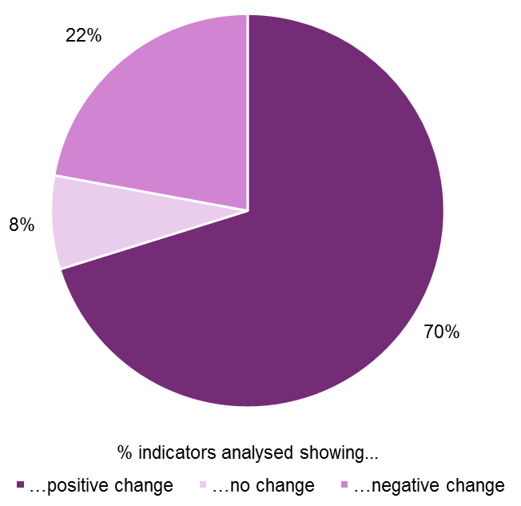
Source: LGA evaluation of sector-led improvement – data analysis report, May 2018

Leadership
We know that local government is only ever as vibrant, effective and relevant as the people running it. So we have a duty to support and challenge the politicians of today to be the best leaders they can and to encourage and talent spot the best leaders for the future.
The LGA’s Highlighting Leadership offer provides a range of programmes, events and resources aimed at supporting and developing councillors at all levels and helping them progress through the various stages of their political careers.
This section contains a summary of feedback collected from participants in the following LGA leadership development programmes, as well as summarising research on the longer term impact that these programmes have had on participants:
- Leadership Academy - the LGA's flagship development programme for councillors in senior leadership positions
- Leadership Essentials - a series of events designed as themed learning opportunities for councillors concentrating on specific portfolio areas, such as planning or children's services, or a specific theme, such as communications or digital leadership
- Next Generation – a party political development opportunity for ambitious and talented councillors
- ngdp – a two year graduate management development programme.
The level of satisfaction with leadership programmes is consistently high
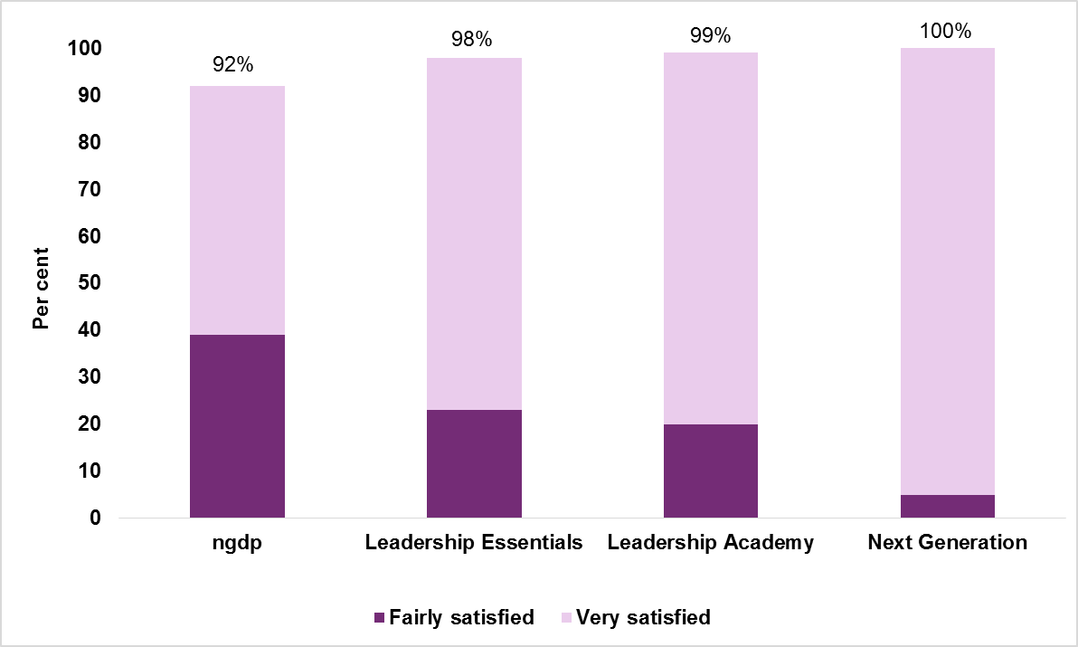
Source: LGA evaluations of leadership programmes 2017 and 2018
Base: ngdp (49 respondents), Leadership Essentials (430 respondents), Leadership Academy (101 respondents), Next Generation (38 respondents)
Of those councillors that attended the Leadership Academy in 2017/18 and provided feedback, 99 per cent were either very or fairly satisfied, whilst 97 per cent reported that taking part had made them more confident in their ability to carry out their role, to either a great or a moderate extent.
Ninety three per cent said that their objectives for taking part in the Leadership Academy had been fully or largely achieved, with a further five per cent saying that their objectives had been partially achieved. All but one respondent (99 per cent) indicated that they would be likely to recommend the Leadership Academy to fellow councillors if asked about it.
“The Leadership Academy has really helped me to understand how I work with my colleagues and communities and get me out of the mind-set that only sees barriers and not opportunities.”
Leadership Academy 2017/18 attendee
Looking at longer term impact, in a November 2017 survey of councillors who had graduated from the Leadership Academy five months previously, 94 per cent (46 respondents) said that the programme had helped them improve the way they carry out their role, to either a great or moderate extent.
Forty-seven per cent (23 respondents) had progressed to a new role or taken on additional roles or responsibilities since participating in the Leadership Academy. All of these respondents said that their participation in the programme had a positive impact on their ability to do this.
“Since undertaking the academy I became opposition leader, I believe the course gave me the confidence and tools to undertake the role.”
Leadership Academy 2016/17 attendee
Councillors that attended a Leadership Essentials course in 2017/18 were given paper feedback forms to complete. Amongst those that responded, nearly all (98 per cent) said that they were either very or fairly satisfied with the course they attended. Further, 96 per cent said that the course had increased their confidence in their ability to carry out their role, to either a great or moderate extent.
The majority of respondents (89 per cent) had fully or largely achieved the objectives they had for taking part in the course. Almost all (98 per cent) said they would be likely to recommend Leadership Essentials to fellow councillors if asked about it.
“As a member new to scrutiny, it has opened my eyes to how to add value to decision making. Talking with more experienced councillors, who have also found new revelations, makes me think I’ll be back to learn more.”
Effective Scrutiny Leadership Essentials course attendee 2018
Surveys are also conducted several months after councillors have completed their Leadership Essentials courses, looking at the extent to which this has had a lasting impact on participants. Amongst survey respondents who had attended a course in 2017/18, the majority (92 per cent) said attending this had helped them improve the way they carried out their role, to either a great or moderate extent.
Thirty one per cent had progressed to a new role or taken on additional roles or responsibilities since attending a Leadership Essentials course. Of these, 82 per cent said their participation in the programme had a great or moderate positive impact on their ability to do this. A further 10 per cent said that they expected to progress soon.
“I now feel a great deal more confident in accepting media requests to speak or give interviews.”
Working with the Media Leadership Essentials course attendee 2017
Of those councillors that attended Next Generation in 2017/18, all those who responded to the feedback survey (38 respondents) said that they were either very or fairly satisfied with the programme. Further, all said that Next Generation had helped them feel more confident in their ability to carry out their role, to a great or moderate extent. All had largely or fully achieved the objectives that they had for taking part in the programme, and all said they would be very or fairly likely to recommend Next Generation to fellow councillors if asked about it.
“One of the most unique courses I have ever taken in local government. If you want to network with passionate councillors from around the country, learn from leading experts and make your mark as part of the next generation - this course is for you.”
Next Generation 2017/18 attendee
Looking at longer term impact, in a 2017 survey of councillors who had completed the Next Generation programme seven months previously, 97 per cent (38 respondents) said that the programme had helped them improve the way they carry out their role, to either a great or moderate extent.
Sixty-seven per cent (26 respondents) had progressed to a new role or taken on additional roles or responsibilities since their participation. Of these respondents, all said that the programme had had a great or moderate positive impact on their ability to do this.
“Several aspects have been totally vital. Media training, dealing with problems, I approach problem solving differently and far more successfully than previously.”
Next Generation 2016/17 attendee
In 2017 and 2018, surveys were undertaken of graduates who had just completed the ngdp. Of those who responded in 2017, 85 per cent were very or fairly satisfied with the ngdp, with 92 per cent (45 respondents) very or fairly satisfied in 2018. In 2017, 85 per cent said they felt greatly or moderately more confident in their ability to gain a management position in local government, having participated in the ngdp, and 92 per cent (45 respondents) said this in 2018.
In 2017, 77 per cent said that the objectives they had for taking part in the ngdp were largely or fully achieved, and 88 per cent (43 respondents) said this in 2018. In 2017, 95 per cent said they would be likely to recommend the ngdp to others if asked about it, with 98 per cent (48 respondents) saying this in 2018.
“The strength of the ngdp is in the training and events arranged by the LGA… the training modules and qualification was excellent and I do believe taking part in the ngdp has fast-tracked my career.”
ngdp 2018 graduate
Looking at the longer term impact of ngdp, two surveys of graduates who had completed the ngdp a year earlier were conducted in 2017 and 2018. In 2017, 77 per cent of those who responded were still working in local government (70 per cent – 33 respondents in 2018). Ninety-one per cent (40 respondents) of those that still worked in local government in 2017 said that participation in the ngdp had helped them improve the way they carry out their current role to a great or moderate extent, and 91 per cent (30 respondents) also said this in the 2018 survey.
In 2017, 89 per cent (39 respondents) of those that still worked in local government had progressed in their career or taken on additional roles or responsibilities since participating in the ngdp, with 91 per cent (30 respondents) saying this in 2018. In 2017, 97 per cent (38 respondents) said that their participation in the programme had a great or moderate positive impact on their ability to do this, with all relevant respondents saying this in 2018.
“My current role and progress in my career to date is all down to the NGDP which has given me not just the technical abilities I need to be a manager within local government, but also the confidence to put forward my own ideas, create change and lead even in challenging situations!”
ngdp 2017 graduate

Peer challenge
Peer challenge is a proven tool for improvement. It is a process commissioned by a council and involves a small team of local government officers and councillors spending time at the council as peers to provide challenge and share learning.
Improvement support provided by one’s peers is effective because peers bring with them their practical knowledge and experience of working in local government and the challenges councils are facing. This means that they are able (much more so than inspectors or private consultants) to:
- understand the challenges councils are facing and get to the heart of the issue
- challenge any misunderstandings or unrealistic expectations held locally
- provide practical advice based on real experience
- offer advice in a way that is sensitive to local dynamics.
And because the advice and support is perceived to be coming from people who know what they are talking about, it is much more likely to be accepted and acted upon than if it was coming from those with little or no practical experience.
In early 2017, an independent evaluation of the corporate peer challenge (CPC) programme was published. The evaluation consisted of a range of activities, including documentary analysis, workshops, interviews and case studies. The report provided a range of recommendations, which have informed the improvement and development of the CPC process. Key findings included:
- Effectiveness: CPC is an effective tool at the heart of the SLI programme. The ability for councils to choose the timing of their peer challenge continues to be an important feature. So too does the focus on the five core components of priority setting, leadership, governance, finance and capacity. The quality of the peer team is key, and it is important to remain focussed on peer recruitment and continue to strengthen training for peers. The feedback processes during a CPC, including the final report, all have value. It is important to make sure reports continue to be written constructively to inform and support improvement, while also providing sufficient information to enable councillors and the public to hold the council to account. There is also a need to consider how follow-up visits are applied, ensuring a focus on delivering them in the councils that will most benefit from them.
- Impact: CPC is having a positive impact for participating councils and the sector as a whole. The extent of that impact is determined by how councils approach and react to a peer challenge. These impacts tend to occur in five main areas, all of which are helpful in ensuring councils are best placed to meet the challenges they face. CPCs have helped provide reassurance; improve external reputation; prompt behaviour change; informed organisational change; and supported service transformation and financial sustainability. For many councils, what happens after the CPC is as important as the peer challenge itself. The process can be a trigger for a set of activities and support from the LGA that have had further impact on improvement. There is a need to promote CPC more by using ‘impact stories’ from those who have had one to show how the process helps councils to improve and to encourage all councils to have one.
- Value for Money: The CPC programme provides value for money. Peer challenge is a good example of the sector helping itself by providing improvement support at a lower cost than is available through external consultancy. Not only is it cheaper, there are considerable added benefits from it being peer-led. While there are costs to the LGA in managing peer challenges and officer time is needed by councils receiving them, the value of CPC should not simply be evaluated on a unit cost basis. There are a range of benefits that offer a return on the cost and investment. Councils benefit in several ways from being involved in a process of peer learning. Peers gain new insights on how other councils operate and have the opportunity of bringing back learning to their own organisation in ways that both improve service outcomes and drive efficiency. CPC is a catalyst for a range of activity and support (both formal and informal) which is valuable but difficult to put a price on. Additionally, these mechanisms can act in consort to help prevent failure and the more significant financial costs of intervention.
Feedback surveys of councils who received CPCs during 2017/18 reaffirm the messages from the earlier independent evaluation. Ninety-eight per cent of the chief executives and leaders who responded to the feedback surveys said that they were very or fairly satisfied with the CPC their council received.
Ninety-three per cent said they felt more confident about their council delivering its priorities, having participated in the CPC, to either a great or moderate extent. The same proportion said they had fully or largely achieved the objectives that they had for taking part in the CPC. Nearly all (99 per cent) of respondents said that they would be either very or fairly likely to recommend having a CPC to other councils, if asked about it.
“The review was everything we had hoped for. It provided us with a reflective robust challenge whilst at the same time was forward looking helping us to refine and improve on our strategic thinking and direction.”
Chief Executive
Further, impact surveys undertaken around one year after, amongst chief executives and leaders of councils who had a CPC in 2016/17, looked at the extent to which the peer challenge had a lasting impact on the council. The area where a great or moderate positive impact was most commonly seen was ‘delivery of the councils priorities’, with 80 per cent of respondents saying this. This was followed by the ‘the external reputation of the council’ (72 per cent). Full details can be found in the chart below.
One year on, CPCs continue to have a range of positive impacts on participating councils. Councils were asked the extent to which the CPC had a positive impact on:
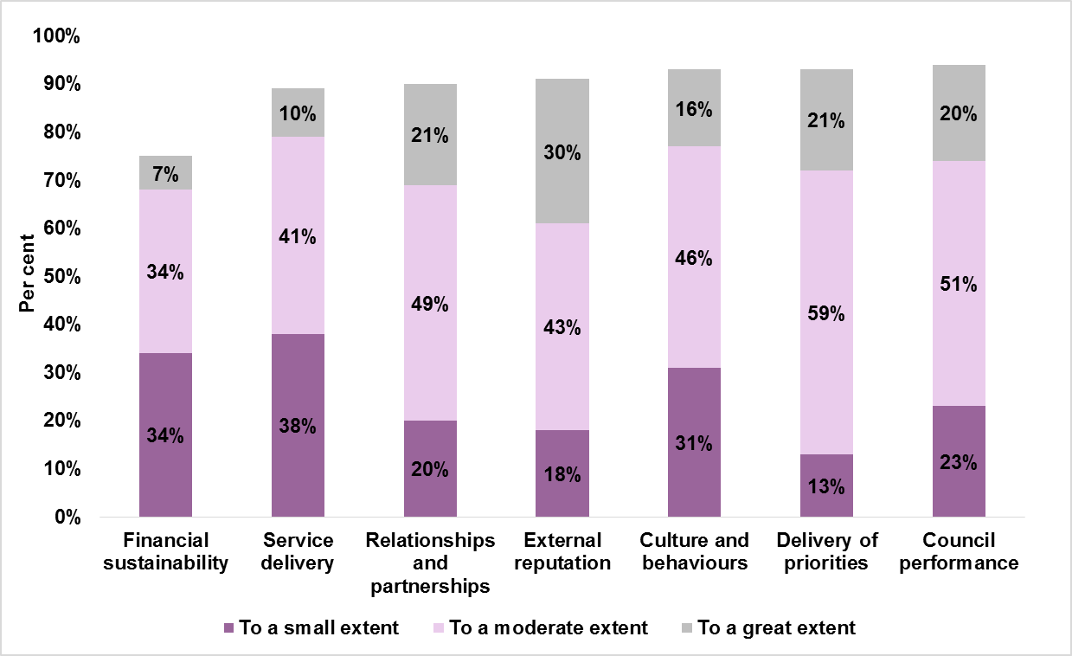
Source: LGA impact evaluation of CPCs which took place in 2016/17
Base: all chief executives and leaders who responded to the survey (61 respondents)
In April 2018, the LGA began surveying those who took part in peer challenge teams. As at the end of September 2018, a total of 39 responses had been received – a response rate of 65 per cent. The key findings were:
- All respondents were very or fairly satisfied with their experience of being part of a peer challenge team, and 97 per cent said they would be likely to recommend being a peer to a colleague if asked about it, based on their experience of taking part.
- Ninety-seven per cent23 said that being part of the CPC had a great or moderate positive impact on their own personal learning and development.
- Ninety per cent took away new ideas or good practice, either from the peer challenge authority or from other peer team members, which they would consider implementing in their own authority.
“Being part of the team was a really worthwhile experience; I took away lots of ideas from the host authority and from the other peers that I can use to improve practice in my own authority. As always with peer challenges it was a few days very well spent.”
Peer team member 2018/19

Productivity
Increasingly councils are looking to the LGA for support in managing their costs and demand pressures and finding new ways of developing alternative income streams in order to reduce their financial dependence on government and their call on local taxpayers.
The LGA’s efficiency and productivity programme provides a range of support to help councils achieve this, grouped into three broad areas.
- Transforming services: either to make them more efficient and less wasteful or to find more effective ways of delivering to meet local people’s needs.
- Smarter sourcing: commissioning and buying the services, goods and works that contribute to local outcomes more effectively and, where possible, more cheaply.
- Generating income in order to maintain delivery in response to local priorities and reducing public finances.
This section contains a summary of the evaluation findings for the following programmes:
- Productivity Experts – which offers councils the chance of support from one of the LGA's ‘pool’ of productivity experts, to help them deliver efficiency savings or generate income.
- The National Procurement Strategy – which, in 2014, set out a vision for local government procurement and encourages all councils in England to engage with the delivery of outcomes in four key areas – making savings, supporting local economies, leadership and modernising procurement. The strategy was updated in 2018.
- Commercial skills training – a six day programme aimed at senior officers.
- Digital Transformation Programme – which supports a range of projects to develop and implement leading edge digital tools and approaches to support councils’ existing work on major programmes of local service transformation.
An external evaluation of the Productivity Experts Programme was carried out in 2016. At the point the evaluation was undertaken, a total of 48 projects had been supported. Over the 25 projects for which the evaluation could capture savings and income data, it was estimated that the programme supported projects which achieved financial benefits in the vicinity of £133 million, including both achieved and expected future benefits. This was comprised of around £131 million in savings and £2 million in income generated. This equates to an average financial benefit of £5.3 million per project.
Councils reported that the benefits had been achieved in a number of different ways. For some councils the financial benefits had been achieved through improving the performance of services, reducing the cost of processes and through better focus on the existing demand. For others, savings had been achieved through improved contractual terms/rates, with the benefits in terms of negotiation extending well beyond the specific project they initially sought support for, as the skills become embedded in the organisation.
Since the evaluation, some further case studies have been carried out, with some examples of positive outcomes from these projects summarised below.
Harrow Council: The Productivity Expert project agreed a new commercial property investment strategy that aims to deliver higher rates of return than previous investment options. This has led to new acquisitions and revisions in the way existing portfolio stock is viewed. The Investment Property Strategy, approved as a result of their work with the Productivity Experts Programme, expects a gross yield of 7.5 per cent from new investments.
The Exeter and Heart of Devon Shared Economic Strategy 2017 - 2020: This was awarded the accolade of ‘Most Innovative Strategy’ in a national awards programme run by the Institute of Economic Development. The Productivity Experts Programme offered technical advice and guidance that was instrumental in progressing the strategy and designing a new framework for collaborative economic development across the four local authority areas.
This focus on collaborative working is already delivering tangible outputs beyond what could be achieved in isolation. For example, the councils were able to commission a high-quality business support service with funding from a pooled budget and have also established a shared system to manage inward investment data.
In winter 2017, a series of telephone interviews were undertaken with eight senior council officers on the impact of the 2014 National Procurement Strategy on their councils. All respondents were very positive about the strategy, noting that it was produced at the right time and supported activity that authorities were, at that time, beginning to undertake, with the result that they had taken a more strategic direction than would otherwise be the case. There was recognition that the strategy had focused on the key issues that it was felt that local government needed to improve on and, in this way, it had achieved its aim.
This said, there was some discussion around the need for revised guidance to ensure continued applicability. Respondents added they knew that the LGA was aware of this, and shortly after the evaluation, an updated 2018 strategy was published.
Whilst some interviewees couldn’t quantify specific monetary savings as a result of the 2014 strategy, others did give examples, and these are outlined below:
- Two million pounds achieved in savings.
- A group of councils in a consortia had achieved combined savings of around £13m since the 2014/15 financial year.
- £23m in savings over the last three years.
- Savings in the 2016/17 financial year were £1.6m in addition to cost avoidance savings of around £100,000.
Two phases of evaluation of the LGA commercial skills training programme were carried out. The first consisted of six telephone interviews in July 2017 with chief executives and senior officers who attended the pilot training programme in summer 2016. The second consisted of ten interviews with the first two cohorts, conducted during autumn 2017. Key findings included:
- Impact: Participants from both phases reported that the training gave them a greater understanding of commercialisation, a private sector perspective on commercialisation and also a comprehensive understanding of issues and approaches relating to setting up trading or limited companies. Those from cohort one and two of the programme said they benefitted from networking opportunities and from an increase in confidence which allowed them to share their knowledge of commercial activity and delivery models within their council.
- Council activity and innovative practice resulting from training: Though some examples were given it was generally felt to be too soon to identify many details of activity resulting directly from the training. All participants noted however that the training had impacted on their general ethos and approach and had provided an improved knowledge and understanding of commercial activities. Participants from cohort one and two reported an increased positivity and confidence which had resulted from the training and an ability to cascade course learning and disseminate knowledge throughout their council, leading to a greater corporate understanding of commercialisation. Participants said that the training had provided both strategic and operational knowledge which would allow them to progress with commercialisation within their authority.
- Commercial activity income generation: Respondents gave a variety of examples of commercial income generation activity in which their councils were already engaged. For example, a joint venture that originally delivered waste services that has diversified and grown into delivering other services such as an MOT station and the provision of facilities management services. Income has been generated in the first year of this venture and specific contracts are providing savings and have achieved around £250,000 of new income in the first twelve month period.
Some examples of impact on practice are given in the box below.
Following the training:
- One council was actively working towards a transition to trading through a shared services venture.
- Another was discussing adopting a profit/loss approach for the way it reports on its finances. This developed from aspects of the course focused on more effective approaches to managing budgeting processes, specifically around services that trade or generate income.
Overall, respondents were positive about the training, describing it as excellent quality, valuable, well delivered and to be recommended. Interacting with colleagues from other councils, learning about their work and developing links and networks as a result were highly valued by participants.
The Digital Transformation Programme set out to support councils to use digital tools and solutions to support their work on national programmes of transformation, including troubled families, integrating health and social care and managing demand for housing. A review of these projects was carried out in the spring of 2018. The review focused on nine of the 20 originally funded projects, which had made significant progress by that point. Case studies were captured for these nine projects, which identified three key overarching benefits of the programme:
- Financial savings in excess of £2.3 million: by reducing the volume of unsuccessful or inappropriate applications, integrating and automating processes, reducing avoidable phone or face-to-face contact, eliminating rekeying of data, cutting printing and postage costs, making better use of in-house systems and expertise, identifying future problems and intervening earlier and in a more focused way.
Staff in Worcestershire now benefit from a much smoother and more integrated process for handling referrals, while in East Sussex the forms used in the Troubled Families processes have been significantly improved.
- Better support to residents: by providing a more joined-up and integrated service, better targeting of support to those who need it, improving online service options, completing referrals and assessments more rapidly, connecting people to a range of voluntary services, and providing a personal action plan where the council is unable to help.
An important element of Adur and Worthing’s project was the development of a directory containing details of a wide range of local services, community groups, events and other assets. ‘Community referrers’ use the directory to signpost residents to appropriate support.
- More productive ways of working for councils and their partners: by enabling new service delivery models, developing a clearer understanding of local need, demand and take-up and the impact of current patterns of service provision, better targeting of staff resources, creating new capabilities and improving staff skills, morale and work allocation, fostering greater collaboration with other service providers, and providing better intelligence to central government and key partners.
In Wigan, the digital transformation project has been a key enabler of the council’s new delivery model, which offers services on a coordinated, area-based and multi-agency basis.
The review reinforced the benefits that these ambitious and complex projects have delivered, as well as highlighting the vital role that digital tools and technologies continue to play in supporting customer-focused innovation in local government. However, developing and implementing such projects is by no means easy, and some clear messages about how to maximise the likelihood of success have emerged. These are:
- focus constantly on users and test often
- engage, engage, engage – ‘upwards’ (e.g. with councillors), ‘sideways’ (e.g. with partners) and ‘outwards’ (e.g. with frontline staff and residents)
- make sure the right project personnel are in place
- think organisational culture – to ensure that staff see the change as liberating rather than threatening
- don’t expect partnering to be easy
- anticipate technical challenges
- make sure the resources are in place.

Data Experts Programme
The Data Experts Programme ran between November 2016 and March 2017. It provided eight councils with support to develop projects that encouraged better use of local data with the support and help of other data experts or local government partners.
A number of case studies of some of the councils who received the grant funding were carried out in early 2018. Some of the initial outcomes being seen from these projects are summarised below.
West Sussex Council: The council used the grant to expand upon a successful local initiative by developing a virtual national experts’ forum, called the Data and Insight Authority Forum, to share and make better use of information and data on a wider scale.
Data experts within authorities are now regularly interacting with each other via mechanisms provided by the forum. Previously some authorities felt the need to call in external consultants for support but are now easily able to access expertise from peers. Longer term savings are likely to be seen from avoiding a duplication of effort throughout the wider local government sector.
Leicester City Council: An early intervention project consisting of a team from each of the emergency services in a deprived area of the city hoped to engage more with other local services to make the best use of data and to identify the underlying causes for individuals calling blue light services.
The short term impact of using the data expert has brought partners together and broken down perceived cultural and legal concerns and barriers allowing the project to move forward. Data processing agreements are now in place as well as information sharing agreements. As a result, data is now being shared more effectively and work is being undertaken jointly by partners.32,

LG Inform
We know that having good performance data and information – and being able to make comparisons with other councils – is a key driver of improvement.
LG Inform is the LGA’s data and benchmarking service. This free, online service allows anyone in councils and fire and rescue services to access and compare both contextual and performance data for their local area. Authority users can view data or pre-written reports, and create their own reports using the most up to date published information.
In early 2018, an online survey was sent to all registered users of LG Inform. Key findings from this survey included:
- At 65 per cent, a majority of respondents found LG inform either very or fairly useful. It is worth noting though that 23 per cent answered ‘don’t know’ or ‘not applicable’; these were generally very occasional users.
- Of those respondents who estimated how much time using LG Inform saves them, on average, every hour of usage resulted in time savings of 1 hour and 23 minutes.
- Eighty-four per cent of the respondents who had participated in LG Inform training reported that it improved their performance in their role to some extent, with 40 per cent saying this was to a great or moderate extent.
- Respondents were asked what contribution, if any, the data they extract from LG Inform make to a variety of strategic decision-making activities within their organisation. Performance management was most commonly identified as being influenced by data outputs from LG Inform (60 per cent), followed by informing decision-making (58 per cent).
LG Inform key statistics | - LG Inform has 3,437 registered users and has had over 1.3 million page views since its launch  - many more people use the tool without signing in  - 785 new users registered in the last year  The most popular reports in the last year were:  - special educational needs and disabilities, with 8,842 views  - delayed transfers of care, with 2,614 views  - personal wellbeing in your area, with 1,806 views

Housing Advisors Programme
The Housing Advisers Programme was introduced in 2017/18 and is designed to support local authorities to deliver a project that helps meet the housing need of their local area. The programme funds the provision of an independent adviser to offer bespoke expert support to local authorities undertaking a specific project that works towards delivering homes, reducing homelessness, or generating savings or revenues.
A small number of case studies looking at initial outcomes from the projects were carried out in early 2018. Some examples are summarised below, and further evaluation in early 2019 will look at medium term impacts.
Purbeck Council: The support generated a clear plan of action, with a range of options for increasing the supply of private rented accommodation, preventing homelessness arising from private rented sector housing and meeting the new duties of the Homelessness Reduction Act. The implementation of the plan has the potential to deliver significant savings. In addition, there will be a reduction in the number of households in emergency temporary accommodation.
Warwick Council: The support has led to good progress in developing the Student Housing Strategy project for the area. The completed strategy will have a set of clear SMART actions and targets to take forward. Longer term this is anticipated to lead to a thriving student community in the district, with an adequate amount of appropriate housing, well-integrated into the community.
In addition, in February 2018 a survey was conducted of the first cohort of councils, asking about satisfaction with various aspects of the programme. Satisfaction with the application process was high, for example 94 per cent (32 respondents) were very or fairly satisfied with the applications criteria. Responding council’s satisfaction with their advisors was also high, for example 91 per cent (31 respondents) said they were very or fairly satisfied with their authority’s relationship with their advisor, whilst 94 per cent (32 respondents) said their advisor understood their project to a great or moderate extent.

Local Partnerships
Local Partnerships is a joint venture owned by the LGA in partnership with HM Treasury and the Welsh Government. It provides commercial expertise in relation to projects and change programmes such as PFI programmes, regional waste studies, shared services, housing etc. and assists in the development of new services and programmes aimed at creating a pipeline of future funding streams.
A feedback form was sent to the client contact in each of the 34 councils with which Local Partnerships had greatest degree of contact and that received grant funded support since 1 April 2017. As at the end of September 2018, a total of 26 responses had been received – a response rate of 76 per cent.
Twenty one of these respondents (81 per cent) said that Local Partnerships had fully met their requirements, with all remaining respondents (19 per cent) saying that their requirements were exceeded.
“We appreciated the availability of the team to provide support, with timely responses to questions and queries. Technical support has been impressive.”
Energy performance contracting

“Local Partnerships helped the council in wanting to tackle the issue of micro-commissioning in a time when we were seeing increasing market failure and a real drive to wanting to support small businesses in the world of health and social care. Local Partnerships fully met our requirements and [we] couldn’t have done this without the additional skills and capacity that Local Partnerships brought to this work.”
Health and social care support

“The workshop was a great opportunity to share ideas and network and the report was a good record of what is happening across the region and getting access to information that isn't always shared because of the day job and the time pressures.”
Waste management – regional savings review

One Public Estate
The One Public Estate (OPE) Programme was established as a partnership between the LGA and the Office for Government Property (OGP) in 2013. It aims to ensure a more joined-up approach to the management of land and property in public ownership and to facilitate greater collaboration between local and central government agencies to support economic growth (new homes and jobs) by freeing up land for the development of housing and employment uses; generating efficiencies through capital receipts and reduced running costs; and delivering enhanced, more integrated and customer-focused public services.
As at October 2018, the programme involved 319 councils working together in 76 partnerships, delivering approximately 450 projects. By 2020 these projects are expected to deliver £615m in capital receipts and £158m in running costs savings, create 44,000 jobs and release land for 25,000 homes.
An independent evaluation was carried out in 2018. This assessed the performance of the programme, to date, against its objectives using a ‘mixed methods’ approach, combining quantitative and qualitative evidence and analyses, including assessment of monitoring and performance data, case studies and consultations with key stakeholders. Key findings of the evaluation included:
- The underlying rationale of the programme remains as relevant today as it was in 2013. Its flexible framework - delivering economic growth, integrated services and efficiencies – has enabled OPE to respond to changing priorities within both local authorities, local OPE partnerships and central government.
- The programme has performed well against its ‘coverage’ target with local partnerships covering around 79% of local authorities in England across phases 1-5. At the time of the evaluation it covered over 400 projects, in 63 partnership areas, spanning wide-ranging policy themes. It has facilitated partnerships between local authorities and multiple central agencies including the Ministry of Defence, Ministry of Justice, Department for Work and Pensions and the NHS. Since completion of the evaluation OPE has further expanded and covers 90% of English local authorities.
- The OPE programme has contributed significant added value in facilitating a more collaborative culture in estates planning within its local partnership areas.
- ‘Honest broker’ was one of the most common terms used by consultees in describing the role of the programme. The independence and objectivity of the programme as a ‘third party’ in partnership negotiations is viewed as important.
- The case studies highlighted the importance of OPE as a scarce source of revenue funding to support feasibility work. This funding has been critical in seeding and unlocking projects.
- Being engaged in the programme has also had a ‘badge effect’ in several localities, adding credibility to projects that might otherwise have been deemed as too risky or non-priorities. This ‘badge effect’ has helped to smooth decision-making processes and lever in partner resources.
- The early stage feasibility role played by OPE means that the overwhelming majority of the projects it has supported have not yet been delivered and remain ‘in the pipeline’. The programme has delivered only a small proportion of its forecast outputs, to date; however, this aligns with anticipated delivery timelines.
- OPE’s targets for 2020 appear to be a realistic estimate of likely outputs. But, successfully meeting these targets will require a step change in the scale of output delivery relative to what has been achieved to date.
The report concluded with recommendations (for example around more effectively engaging with central government departments) and a strategic assessment of future funding and operational models for the programme, which will be used to inform the future direction of OPE.

Further evaluation
The focus of this evaluation report has been to look at the effectiveness and impact of improvement support designed to strengthen and improve councils’ corporate leadership and capacity.
Separate improvement programmes have operated in children’s services and in adult social care and health. These programmes have been developed and delivered in line with the overall principles and support offers of the generic approach to SLI, and have undertaken their own evaluation work. For example:
- In children’s services independent action research into improvement identified seven important enablers of improvement, the most important of which were the strategic approach (for example development of a vision and strategic plan that are right for the organisation) along with the quality of political and senior managerial leadership.
- Similarly an independent evaluation of the Care and Health Improvement Programme (CHIP) undertaken in 2016 confirms that “…. there is substantial evidence that CHIP has had a significant positive impact on the performance of councils and their partners”.
The LGA will continue to closely monitor the effectiveness of the SLI offer. In addition to the ongoing elements of evaluation mentioned in the body of the report, further evaluation activity which is planned or already underway includes:
- Feedback and impact surveys of councils that have received bespoke workforce support.
- Feedback surveys for a range of officer leadership programmes (for ‘rising talent’ through to chief executives) carried out in partnership with SOLACE.
- Feedback and impact surveys of councillors who have received peer mentoring support.
- An impact survey of the first cohort of councils to participate in the Housing Advisors programme.

Annex B: Supporting reports
The main pieces of research drawn upon are listed below, with links to individual reports for each element, including full details of the methodologies and the full sets of results.
- Time series data analysis of key performance metrics for local government.
- A series of telephone polls of representative random samples of approximately 1,000 British adults (aged 18 or over) carried out quarterly between September 2012 and June 2018.
- A ‘perceptions survey’ of the LGA membership, comprising a total of 1,004 interviews with a sample of representatives from councils across all the English regions (including chief executives, directors, leaders, chairs of scrutiny, portfolio holders, frontline councillors and leaders of the opposition). This is the sixth year the survey has been conducted.
- Evaluations of the key individual offers of LGA support for sector-led improvement:
  - Leadership programmes
  - Peer challenge
  - Productivity experts
  - National procurement strategy
  - Commercial skills training
  - Digital transformation
  - Data Experts
  - LG Inform
  - Housing advisors
  - Local Partnerships
  - One Public Estate
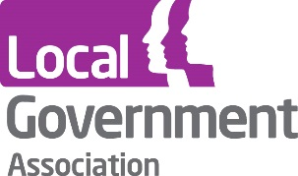
Local Government Association
18 Smith Square
Westminster
London SW1P 3HZ
Telephone 020 7664 3000
Fax 020 7664 3030
Email info@local.gov.uk
www.local.gov.uk

© Local Government Association, November 2018
For a copy in Braille, larger print or audio, please contact us on 020 7664 3000.
We consider requests on an individual basis.

Sector-led improvement: our offer of support https://www.local.gov.uk/sector-led-improvement-our-offer-support-0
Evaluation of sector-led improvement https://www.local.gov.uk/our-support/our-improvement-offer/evaluation-sector-led-improvement
LGA perceptions survey https://www.local.gov.uk/our-support/research/research-publications/lga-perceptions-survey
LGA resident satisfaction surveys https://www.local.gov.uk/our-support/research/research-publications/residents-satisfaction-surveys
For the majority of indicators, the period over which change was assessed was 2009/10 – 2016/17, although this varied according to data availability for each metric.
Evaluation of sector-led improvement: data analysis report 2018 https://www.local.gov.uk/evaluation-sector-led-improvement-data-analysis-report-0
National Audit Office, Financial sustainability of councils 2018 https://www.nao.org.uk/report/financial-sustainability-of-local-authorities-2018/
23 respondents
45 respondents
38 respondents
Rising to the Challenge: An independent evaluation of the LGA’s Corporate Peer Challenge programme: https://www.local.gov.uk/rising-challenge-independent-evaluation-lgas-corporate-peer-challenge-programme
35 respondents
LGA perceptions survey https://www.local.gov.uk/our-support/research/research-publications/lga-perceptions-survey
LGA resident satisfaction surveys https://www.local.gov.uk/our-support/research/research-publications/residents-satisfaction-surveys
For the majority of indicators the period over which change was assessed was 2009/10 – 2016/17 although this varied according to data availability for each metric.
Excluding police, fire and public health (which was transferred to councils in 2013/14)
Evaluation of sector-led improvement: data analysis report 2018 https://www.local.gov.uk/evaluation-sector-led-improvement-data-analysis-report-0
LGA evaluation reports of leadership programmes can be found here: https://www.local.gov.uk/our-support/our-improvement-offer/evaluation-sector-led-improvement
Data was collected for courses that took place between September 2017 and March 2018.
Rising to the Challenge: An independent evaluation of the LGA’s Corporate Peer Challenge programme: https://www.local.gov.uk/rising-challenge-independent-evaluation-lgas-corporate-peer-challenge-programme
Please note that whilst it appears the individual ‘great’ and ‘moderate’ extent categories in the chart sum to 73 per cent, this is actually due to rounding.
CPC feedback and impact survey reports can be found here: https://www.local.gov.uk/our-support/our-improvement-offer/evaluation-sector-led-improvement
38 respondents
35 respondents
LGA productivity experts programme evaluation and case studies https://www.local.gov.uk/our-support/efficiency-and-income-generation/productivity-experts-programme
Harrow council case study: https://www.local.gov.uk/lga-productivity-expert-programme-harrow All icons made by prettycons from www.flaticon.com unless otherwise stated
See page 15 of First Magazine https://www.local.gov.uk/sites/default/files/documents/First%20February%202018.pdf
Digital Transformation programme: an evaluation report https://www.local.gov.uk/our-support/efficiency-and-income-generation/digital/digital-funded-programmes-and-case-studies
The status of the other projects was varied, ranging from those that did not proceed, through to those that were proceeding but were not yet at a point to share learning through case studies. Further details on these projects can be found in the full evaluation report: https://www.local.gov.uk/our-support/efficiency-and-income-generation/digital/digital-funded-programmes-and-case-studies
Icon made by Freepik from www.flaticon.com
Icon made by geotatah from www.flaticon.com
Data Experts programme case studies https://files.esd.org.uk/?text=LGADataExperts&page=1
Icon made by Freepik from www.flaticon.com
Excluding members of the LGA Research and Information team who have been directly involved in the development of the system.
As at November 2018
From 1 September 2017 to 31 August 2018.
Purbeck council case study: https://www.local.gov.uk/topics/housing-and-planning/lga-housing-advisers-programme/housing-advisers-programme-case-0
Warwick council case study: https://www.local.gov.uk/topics/housing-and-planning/lga-housing-advisers-programme/housing-advisers-programme-case-1
One Public Estate programme evaluation: https://www.local.gov.uk/our-support/our-improvement-offer/evaluation-sector-led-improvement
Action research into improvement in local children’s services: https://www.local.gov.uk/cyp-action-research-improvement-local-childrens-services
Evaluation of the Care and Health Improvement Programme, 2016: https://local.gov.uk/sites/default/files/documents/chip-evaluation-report-ma-535.pdf
Evaluation of sector-led improvement: data analysis report 2018 https://www.local.gov.uk/evaluation-sector-led-improvement-data-analysis-report-0
LGA resident satisfaction surveys https://www.local.gov.uk/our-support/research/research-publications/residents-satisfaction-surveys
LGA perceptions survey https://www.local.gov.uk/our-support/research/research-publications/lga-perceptions-survey
LGA evaluation reports of leadership programmes can be found here: https://www.local.gov.uk/our-support/our-improvement-offer/evaluation-sector-led-improvement
LGA CPC feedback and impact survey reports can be found here: https://www.local.gov.uk/our-support/our-improvement-offer/evaluation-sector-led-improvement Rising to the Challenge: An independent evaluation of the LGA’s Corporate Peer Challenge programme: https://www.local.gov.uk/rising-challenge-independent-evaluation-lgas-corporate-peer-challenge-programme
LGA productivity experts programme evaluation and case studies https://www.local.gov.uk/our-support/efficiency-and-income-generation/productivity-experts-programme
National procurement strategy evaluation report https://www.local.gov.uk/sites/default/files/documents/NPS%20Impact%20report%20-%20FINAL%20REPORT%209%204%2018_5.pdf
LGA evaluation reports of commercial skills training can be found here: https://www.local.gov.uk/our-support/our-improvement-offer/evaluation-sector-led-improvement
Digital Transformation programme: an evaluation report https://www.local.gov.uk/our-support/efficiency-and-income-generation/digital/digital-funded-programmes-and-case-studies
Data Experts programme case studies https://files.esd.org.uk/?text=LGADataExperts&page=1
LG Inform evaluation: https://www.local.gov.uk/our-support/our-improvement-offer/evaluation-sector-led-improvement
Housing Advisors Programme survey of local authorities and suppliers https://www.local.gov.uk/our-support/our-improvement-offer/evaluation-sector-led-improvement
In year monitoring was used, therefore no report is available
One Public Estate programme evaluation: https://www.local.gov.uk/our-support/our-improvement-offer/evaluation-sector-led-improvement

